V.L Memorial Public School
475 Vijay Nagar
Chapter - 9 - Questions - Class7th - Maths
CLASS 07 - MATHS (GANITA PRAKASH)

 | Section A
1 | In two right - angled triangles, if the hypotenuse and one side are equal, can the triangles be congruent?  a) No, the side must be opposite the right angle.  b) Yes, this is the RHS (Right Hypotenuse Side) condition.  c) Yes, always congruent.  d) No, because one angle is missing. | [1]
2 | A square has how many lines of symmetry?  a) 3  b) 6  c) 2  d) 4 | [1]
3 | The mirror line is also called -  a) Edge  b) Diameter  c) Line of reflection  d) Vertex | [1]
4 | Mirror reflection changes -  a) Left Right directions  b) Size  c) Shape  d) Top Bottom directions | [1]
5 | If two triangles are congruent under any valid congruence condition, then:  a) Only sides are equal  b) Both corresponding sides and corresponding angles are equal  c) Only angles are equal  d) They may differ in shape | [1]
6 | Rotation means -  a) Stretching  b) Turning around a fixed point  c) Flipping  d) Sliding | [1]
7 | Which of the following is a valid condition for triangle congruence?  a) SSA  b) A+B+C=180°  c) AAA  d) AAS | [1]
8 | A shape that can be folded into two equal halves is called -  a) Similar  b) Rotational  c) Symmetric  d) Congruent | [1]
9 | Sliding a shape without turning is called -  a) Reflection  b) Rotation  c) Translation  d) Inversion | [1]
10 | A figure matches exactly with its mirror image. This means it is -  a) Symmetric  b) Rotated  c) Similar  d) Congruent | [1]
11 | By which of the following conditions can two triangles not be proved congruent?  a) SSS  b) AAA  c) ASA  d) SAS | [1]
12 | A figure that does not have any symmetry is called -  a) Congruent  b) Asymmetric  c) Rotational  d) Regular figure | [1]
13 | Which of the following is NOT a rigid motion?  a) Stretching  b) Translation  c) Reflection  d) Rotation | [1]
14 | When a figure is flipped over a line, the movement is -  a) Enlargement  b) Reflection  c) Slide  d) Rotation | [1]
15 | A pentagon has how many lines of symmetry?  a) 2  b) 4  c) 3  d) 5 | [1]
16 | Which shape has exactly 1 line of symmetry?  a) Rhombus  b) Isosceles triangle  c) Square  d) Parallelogram | [1]
17 | If two figures are mirror images, then they are -  a) Rotated by 90$​^{o}$  b) Enlarged  c) Dissimilar  d) Symmetric about a line | [1]
18 | Which condition guarantees congruence only in right angled triangles?  a) AAS  b) RHS  c) ASA  d) SSS | [1]
19 | Two figures that have the same shape and size are called -  a) Symmetric  b) Congruent  c) Similar  d) Equal | [1]
20 | The line that divides a figure into two identical halves is called -  a) Edge  b) Line of symmetry  c) Diameter  d) Axis of rotation | [1]
21 | Assertion (A): Two triangles with corresponding sides proportional are always congruent.  Reason (R): For congruence, the corresponding sides and angle must be equal, not just proportional.  a) Both A and R are true and R is the correct explanation of A.  b) Both A and R are true but R is not the correct explanation of A.  c) A is true but R is false.  d) A is false but R is true. | [1]
22 | Assertion (A): Each angle of an equilateral triangle measures 60°.  Reason (R): The sum of the interior angles of a triangle is 180°, and all angles of an equilateral triangle are equal.  a) Both A and R are true and R is the correct explanation of A.  b) Both A and R are true but R is not the correct explanation of A.  c) A is true but R is false.  d) A is false but R is true. | [1]
23 | Assertion (A): In an isosceles triangle, the base angles are equal.  Reason (R): All three sides of an isosceles triangle are equal.  a) Both A and R are true and R is the correct explanation of A.  b) Both A and R are true but R is not the correct explanation of A.  c) A is true but R is false.  d) A is false but R is true. | [1]
24 | Assertion (A): If ABC is an equilateral triangle, then each angle is equal to 60°.  Reason (R): An equilateral triangle has all its sides equal and each angle measures 60°.  a) Both A and R are true and R is the correct explanation of A.  b) Both A and R are true but R is not the correct explanation of A.  c) A is true but R is false.  d) A is false but R is true. | [1]
25 | Assertion (A): The ASA condition guarantees the congruence of two triangles.  Reason (R): Two angles and the included side fix both the shape and size of a triangle.  a) Both A and R are true and R is the correct explanation of A.  b) Both A and R are true but R is not the correct explanation of A.  c) A is true but R is false.  d) A is false but R is true. | [1]
26 | Assertion (A): The SSA condition never guarantees the congruence of triangles.  Reason (R): In right - angled triangles, equality of the hypotenuse and one side guarantees congruence.  a) Both A and R are true and R is the correct explanation of A.  b) Both A and R are true but R is not the correct explanation of A.  c) A is true but R is false.  d) A is false but R is true. | [1]
27 | Assertion (A): Knowing only the lengths of two sides is always sufficient to recreate a figure exactly.  Reason (R): The shape of a figure also depends on the angle between the sides.  a) Both A and R are true and R is the correct explanation of A.  b) Both A and R are true but R is not the correct explanation of A.  c) A is true but R is false.  d) A is false but R is true. | [1]
28 | One angle of an isosceles triangle is 50°. Find the measure of the other equal angle if this is the vertex angle. | [1]
29 | What does it mean when two figures are congruent and not similar? | [1]
30 | Find the measure of each angle of an equilateral triangle. | [1]
31 | Is every equilateral triangle also an isosceles triangle? Justify briefly. | [1]
32 | A figure has two sides of lengths 5 cm and 7 cm. Will these measurements alone fix the figure completely? Give a reason. | [1]
33 | Which condition is being used when$∠B=∠Y,BC=YZ,∠C=∠Z$ ?  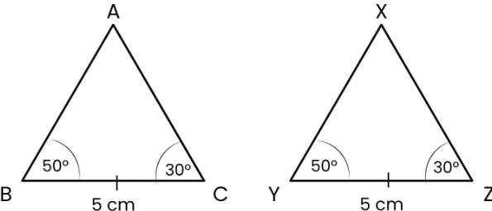 | [1]
34 | Two triangles satisfy AAS condition. Which additional angle becomes automatically equal and why? | [1]
35 | Why can several non - congruent figures be formed with the same two side lengths? | [1]
36 | Two figures can be rotated or flipped and then superimposed exactly. What conclusion can be drawn about the figures? | [1]
37 | In the given figure,$DE=DG$ and $FE=FG$ . Prove that $△DFE≅△DFG$ . | [1]
 | Section B
38 | $AB=AD$ and $BC=CD$ . Prove that $AC$ bisects both $∠BAD$ and $∠BCD$ . | [2]
39 | Define the SSS condition and explain why it guarantees congruence. | [2]
40 | In$△ABC,AB=AC$ , and altitude $AD$ is drawn to $BC$ . Prove that $∠B=∠C$ using congruence.  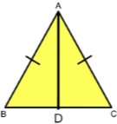 | [2]
41 | In a rectangle ABCD, show that triangles ABD and CDB are congruent. | [2]
42 | Prove that$△XYZ≅△PQR$ given that $XY=PQ,YZ=QR$ , and $XZ=PR$ . | [2]
43 | Why is the SSA condition not reliable for checking congruence? | [2]
44 | The angles of a triangle are${30}^{∘},{70}^{∘}$ , and ${80}^{∘}$ . Explain why these measurements alone are not sufficient to guarantee congruence between two triangles. | [2]
45 | Given that$∠A=∠D,AB=DE$ , and $∠B=∠E$ , show that $△ABC≅△DEF$ . | [2]
 | Section C
46 | $△ABC$ and $△XYZ$ are congruent. If $AB$ corresponds to $XY$ , and $AC$ corresponds to XZ, list the complete congruence relation and explain the correct order of vertices. | [3]
47 | $△ABC$ and $△PQR$ are congruent under the correspondence (matching) $ABC↔RQP$ . Write the parts of $△$ ABC that correspond to  - $\overline{PQ}$  - $∠Q$  - $\overline{RP}$ | [3]
48 | Identify whether the triangles below are congruent. What conditions did you use to establish their congruence? Express the congruence.  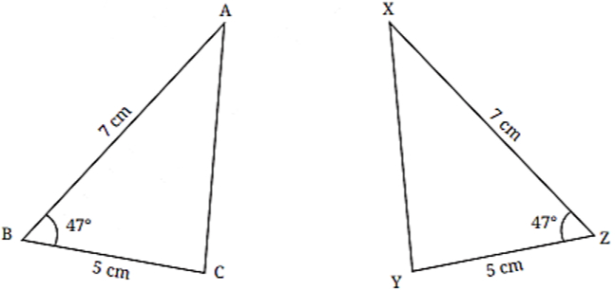 | [3]
49 | If two right triangles have equal legs (not hypotenuse), can we claim congruence? Justify through construction reasoning. | [3]
50 | Which congruence conditions fail when the given triangle elements allow two different triangles to be formed? Explain with example. | [3]
51 | Two triangles have sides$6 cm,8 cm,10 cm$ . One is drawn with between 6 cm and $8 cm={45}^{∘}$ , and the other with the same sides but the angle between them $={60}^{∘}$ . Are the triangles congruent? Justify.  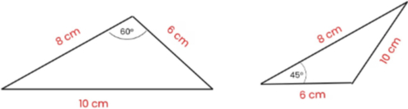 | [3]
52 | In a rectangle ABCD, show that$△ABD≅△CDB$ . Give the correct correspondence of vertices.  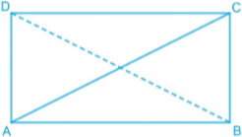 | [3]
53 | $△ABC$ and $△XYZ$ have $∠B=∠Y={50}^{∘},$ $∠C=∠Z={30}^{∘}$ , and $BC=YZ=5 cm$ . Are the triangles congruent? Justify. | [3]
54 | A student claims: "If two triangles have the same three angles, they must be congruent." Is this correct? Prove or disprove. | [3]
55 | Determine whether the triangles are congruent. If yes, express the congruence.  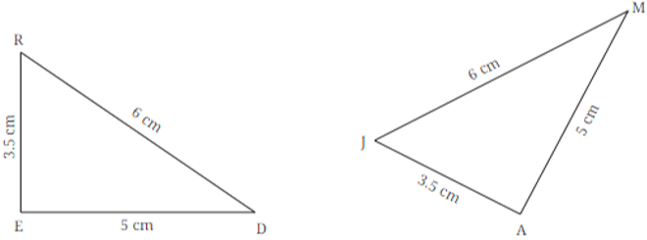 | [3]
 | Section D
56 | Read the following text carefully and answer the questions that follow:  Sunil is a farmer who owns a triangular plot of land. Since the land available with him is limited, he decides to divide it into four parts so that he can practise multiple cropping. The plot is in the shape of triangle $ABC$ . Another isosceles triangle $DBC$ is drawn on the same base $BC$ , such that points $A$ and $D$ lie on the same side of $BC$ . The line $AD$ is drawn and extended to meet $BC$ at point $E$ . The sides $AB=AC$ and $DB=DC$ are marked equal in the figure. Using this division, Sunil plans to grow different crops in plots having equal shape and size.  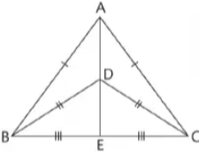  Questions:  - Name the type of triangle$△ABC$ . (1)  - State the condition of congruence that can be used to prove two triangles congruent when all three corresponding sides are equal. (1)  - If Sunil grows crops in$△ABD$ , show that there is another triangular plot of the same shape and size. Name the triangle and give reason. (2)  - OR  - In $△BDC$ , if $∠B+∠D+∠C={180}^{∘}and∠D={70}^{∘},$ find $∠B$ . (2) | [4]
57 | Read the following text carefully and answer the questions that follow:  Amit is a mason who is constructing two triangular stone slabs to cover drainage openings on a footpath. For proper fitting, both slabs must have exactly the same shape and size. Amit measures the first triangular slab and notes that its three sides are5 cm, 6 cm, and 7 cm. Using these same three measurements, he prepares another triangular slab. One slab is placed facing upward, while the other is rotated during installation. Amit wants to confirm whether both slabs will fit perfectly even after rotating one of them. Questions:  - Name anytwo congruence theoremsused to check whether two triangles are congruent. (1)  - Which congruence condition is applicable when all three sides of two triangles are equal? (1)  - Are the two triangular slabs congruent? Give a reason. (2)  - OR  - If instead of three sides, Amit had measuredtwo sides and the angle between themto make the second slab, (2)  - which congruence theorem would be used?  - Would the slabs still be congruent? Give reason. | [4]
58 | Read the following text carefully and answer the questions that follow:  Kushal is a property dealer. He has been in this business from past 12 yr. He bought a triangular shaped plot. It divides the plot into four parts which is shown in the figure.  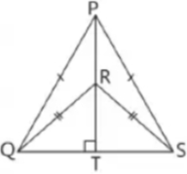  Questions:  - $In△QRS,$ $∠RQS={50}^{∘}.$ $Find∠QSR​$ . (1)  - Name the type of triangle$△QRS$ . (1)  - If$∠QPS={60}^{∘}$ , find $∠QPT$ . (2)  - OR  - If Kushal decides to sell two plots, show that the two triangles $△PQR$ and $△PSR$ have the same shape and size. (2) | [4]
 | Section E
59 | Given that$∠ABC=∠DBC$ and $∠ACB=∠DCB,$ show that $∠BAC=∠BDC.$ Are the two triangles congruent?  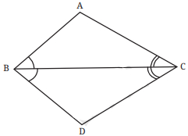 | [5]
60 | Why does the RHS condition work for right triangles even though SSA generally fails?  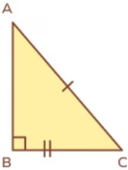 | [5]
61 | You are given two sides$5 cm,7 cm$ and an angle opposite the 5 cm side $={40}^{∘}$ .  Determine whether the triangle is uniquely determined and justify using congruence principles.  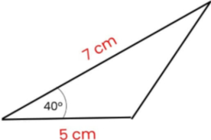 | [5]
62 | A triangle has sides$AB=AC$ . $A$ perpendicular $AD$ is drawn to $BC$ . Explain how RHS congruence proves $∠B=∠C$ . | [5]
63 | Explain all conditions under which two triangles are NOT guaranteed to be congruent.Give examples to support your answer. | [5]
64 | It is given that OB = OC, and OA = OD. Show that AB is parallel to CD.  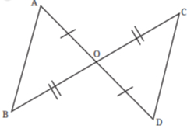 | [5]
65 | In triangle$ABC,AD$ is drawn such that it bisects $BC$ . If $AB=AC$ , explain why $D$ must be the midpoint of $BC$ . | [5]
66 | Prove that if in a triangle two angles are equal, the sides opposite them are equal (using congruent triangles only). | [5]
67 | Given that CD and AB are parallel, and AB = CD, what are the other equal parts in this figure? ( Hint: When the lines are parallel, the alternate angles are equal. Are the two resulting triangles congruent? If so, express the congruence.)  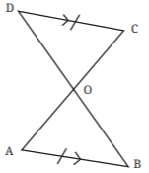 | [5]
68 | You draw$△ABC$ using $AB=7 cm,AC=5 cm$ , and $∠A={50}^{∘}$ . Show that triangle is unique and prove via SAS congruence. | [5]
 | Section F
69 | Fill in the blanks:  - In right - angled triangles, if the hypotenuse and one side of one triangle are equal to the hypotenuse and one side of another triangle, the triangles are congruent by the ________ condition.  - Each angle of an equilateral triangle measures ________ degrees.  - In an isosceles triangle, the angles opposite the equal sides are ________.  - The sum of all interior angles of any triangle is ________ degrees.  - Two figures are congruent if one figure can be ________ exactly over the other.  - The congruence condition in which two sides and the included angle are equal is called the ________ condition. | [6]

